Given an integer rowIndex, return the rowIndexth (**0-indexed**) row of the **Pascal's triangle**.

In **Pascal's triangle**, each number is the sum of the two numbers directly above it as shown:



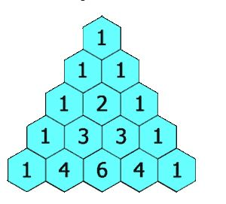

**Example 1:**

**Input:** rowIndex = 3

**Output:** [1,3,3,1]

**Example 2:**

**Input:** rowIndex = 0

**Output:** [1]

**Example 3:**

**Input:** rowIndex = 1

**Output:** [1,1]

**Constraints:**

* 0 <= rowIndex <= 33

**Follow up:** Could you optimize your algorithm to use only O(rowIndex) extra space?